

**NAME.……………………………………………………………....…Class ………………**

**P840/1**

**INFORMATION COMMUNICATION TECHNOLOGY**

**SENIOR THREE TERM ONE 2024**

**TIME: 1HRS**

1. Isaac is currently running a stationery shop where he sells scholastic materials and provides photocopying services only. On daily basis he gets clients inquiring about passport size photographs, business reports, statistical data and formal letters. He is concerned that he may lose some of his customers due to limited services. He contacted a company dealing in ICTs which sent him a brochure bearing some of the ICT tools shown below.





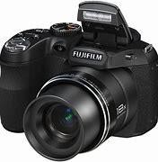

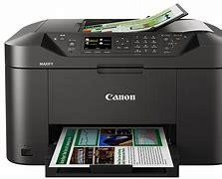

Given limited knowledge on the ICT tools displayed on the brochure, Isaac failed to select which ICTs would be appropriate for his business

**Task**

1. Guide Isaac to select the appropriate ICT tools that will help him improve his services and retain his customers

……………………………………………………………………………………………………………………………………………………………………………………………………………………………………………………………………………………………………………………………………………………………………………………………………………………………………………………………………………………………………………………………………………………………………………………………………………............................................…………………………………

(b) Advise Isaac on how best he can maintain the ICT tools in good working condition.

……………………………………………………………………………………………………………………………………………………………………………………………………………………………………………………………………………………………………………………………………………………………………………………………………………………………………………………………………………………………………………………………………………………………………………………………………………………………………………….......................................................

1. A few days ago, thieves broke into the computer laboratory of a school and stole various equipment. The network server was amongst the stolen equipment and a lot of the school’s important information was lost. As it all happened, some computer parts were broken and scattered all over the laboratory floor. The following morning, the laboratory attendant collected the damaged part in box and dumped them at the garbage pit assuming that most of them would no longer function



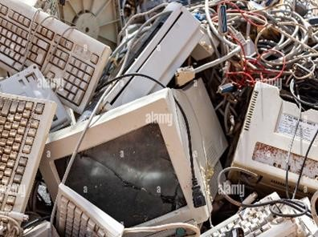

**Task**

(a). Advise the laboratory attendant and the school management on what could have caused such occurrences and the measures they should put in place to prevent similar incidences.

……………………………………………………………………………………………………………………………………………………………………………………………………………………………………………………………………………………………………………………………………………………………………………………………………………………………………………………………………………………………………………………………………………………………………………………………………………………………………………….......................................................

………………………………………………………………………………………………………………………………………………………………………………………………………………….......................................................

………………………………………………………………………………………………………………………………………………………………………………………………………………….......................................................

(b). Demonstrate how the school and other partners can manage the items dumped at the garbage pit

……………………………………………………………………………………………………………………………………………………………………………………………………………………………………………………………………………………………………………………………………………………………………………………………………………………………………………………………………………………………………………………………………………………………………………………………………………………………………………….......................................................

………………………………………………………………………………………………………………………………………………………………………………………………………………….......................................................

………………………………………………………………………………………………………………………………………………………………………………………………………………….......................................................